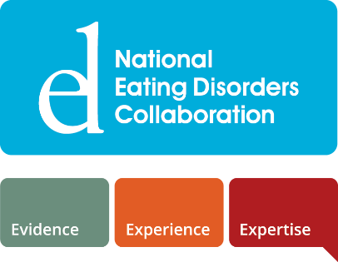

Implementing the National Eating Disorders Strategy – My Action Plan
This resource is designed to support you and/or your organisation or service to identify your role within the stepped system of care for eating disorders and plan for the implementation of the actions relevant to you and/or your organisation or service.
There are five key questions included in this document that will help you with your planning.
If your role sits across multiple components of the system of care (for example, initial response and treatment), you can use the one plan.
- Where does my role sit within the system of care?

Please describe your current role. You may like to refer to the stepped system of care diagram to help you describe the elements of your role and where in the system of care it sits. Your role may be as an individual, and/or as an organisation or service.
My role is:

Click or tap here to enter text.

My role sits within (select all that apply):

☐ | Prevention
☐ | Identification
☐ | Initial Response
☐ | Treatment
☐ | Treatment (community-based)
☐ | Treatment (community-based intensive)
☐ | Treatment (hospital and residential)
☐ | Psychosocial and Recovery Support
☐ | Workforce

*Note: While not a specific component of the stepped system of care, workforce has an integral role in underpinning the system of care. Workforce Standards and Actions are therefore included in the National Strategy, in addition to Standards and Actions for each component of the system of care.

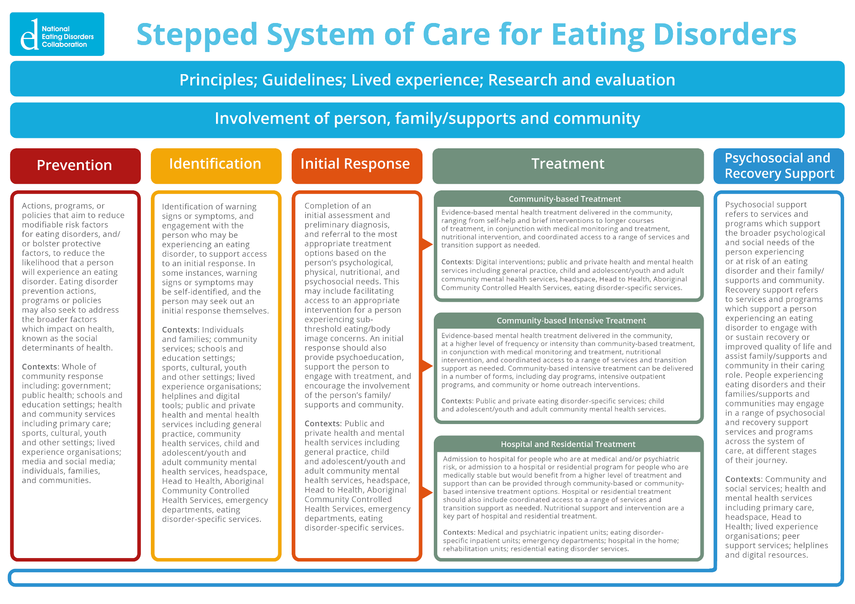

- Which Standards are relevant to my role?

Standards articulate the minimum standard required for each component of the stepped system of care.​ To find the Standards relevant to your role, please see pages 21-25 of the National Strategy.
In the boxes, below, please select the Standards that are relevant to your/your organisation’s role in the stepped system of care.
Component of the  System of Care | Standard/s relevant to my role
Prevention
Identification
Initial Response
Treatment
(including community-based treatment, community-based intensive treatment, and hospital and residential treatment)
Psychosocial and Recovery Support
Workforce

- Which Actions are relevant to my role?

Actions describe what is needed to achieve the Standards. Each Action has been allocated to a particular stakeholder/s. The Actions relevant to your role will sit under the Standards you identified above. The Standards and Actions are organised by a number system. For example, Prevention Standard 3 will have Actions 3.1, 3.2, 3.3, etc.
To find the Actions relevant to your role, please see the following sections:
Prevention | pages 36-40 of the National Strategy
Identification | pages 41-44 of the National Strategy
Initial Response | pages 45-48 of the National Strategy
Treatment | pages 49-64 of the National Strategy  Note that the Treatment section is separated into four sub-sections – Treatment (overarching), community-based, community-based intensive, and hospital and residential
Psychosocial and Recovery Support | pages 65-68 of the National Strategy
Workforce | pages 69-72 of the National Strategy

In the boxes below, please select the Actions that are relevant to your/your organisation’s role in the stepped system of care.
Component | Action/s
Select component | Select Action
Select component | Select Action
Select component | Select Action
Select component | Select Action
Select component | Select Action
Select component | Select Action
Select component | Select Action
Select component | Select Action
Select component | Select Action
Select component | Select Action
Select component | Select Action
Select component | Select Action
Select component | Select Action
Select component | Select Action
Select component | Select Action

- What resources, connections, and partners might I need to support my Actions?

\

Examples
Resources | Connections and Partners
Training and professional development activities | Supervisor/mentor
Clinical tools, e.g., screening and assessment | Communities of practice
Psychoeducation materials | Leaders within your organisation or service
Digital tools | Eating disorder organisations and services, including NEDC
Programs – e.g., existing prevention programs | Clinical support/case consultation​
Clinical services and practitioners | Eating Disorder Coordinators
Psychosocial and recovery support services | Referral pathways
Referral letter templates | Research/evaluation support
Service navigation/databases | Training providers
Standards, principles, guidelines | Education staff (school and tertiary)
Evaluation measures | Media

Using the examples above, or others that you come up with, populate the below table.
Start by selecting the Action in the first column, and then outlining the related resources (middle column) and connections and partners (right column).
My Actions | My Resources | My Connections and Partners
Select Action | Click or tap here to enter text. | Click or tap here to enter text.
Select Action | Click or tap here to enter text. | Click or tap here to enter text.
Select Action | Click or tap here to enter text. | Click or tap here to enter text.
Select Action | Click or tap here to enter text. | Click or tap here to enter text.
Select Action | Click or tap here to enter text. | Click or tap here to enter text.
Select Action | Click or tap here to enter text. | Click or tap here to enter text.
Select Action | Click or tap here to enter text. | Click or tap here to enter text.
Select Action | Click or tap here to enter text. | Click or tap here to enter text.
Select Action | Click or tap here to enter text. | Click or tap here to enter text.
Select Action | Click or tap here to enter text. | Click or tap here to enter text.
Select Action | Click or tap here to enter text. | Click or tap here to enter text.
Select Action | Click or tap here to enter text. | Click or tap here to enter text.
Select Action | Click or tap here to enter text. | Click or tap here to enter text.
Select Action | Click or tap here to enter text. | Click or tap here to enter text.
Select Action | Click or tap here to enter text. | Click or tap here to enter text.

Planning for implementation
You may be able to get started with some of the above Actions immediately, whilst others may take more preparation time.
You can start to map out the sequence of Actions in the table below, ordering them by short-term, medium-term, and long-term. Then, start to create an implementation plan – what steps would you need to take to fully implement that Action?
My Actions | Term | My Plans
List the specific actions specified in Section 4. | Specify if the action is short, medium or long term | Create a plan for implementation. These are specific steps to achieving your goal. For example:  - Create a template referral letter  - Review referral databases  - Plan evaluation for treatment outcome e.g., see National Strategy Evaluation Tool
Select Action | Select term | Click or tap here to enter text.
Select Action | Select term | Click or tap here to enter text.
Select Action | Select term | Click or tap here to enter text.
Select Action | Select term | Click or tap here to enter text.
Select Action | Select term | Click or tap here to enter text.
Select Action | Select term | Click or tap here to enter text.
Select Action | Select term | Click or tap here to enter text.
Select Action | Select term | Click or tap here to enter text.
Select Action | Select term | Click or tap here to enter text.
Select Action | Select term | Click or tap here to enter text.
Select Action | Select term | Click or tap here to enter text.
Select Action | Select term | Click or tap here to enter text.
Select Action | Select term | Click or tap here to enter text.
Select Action | Select term | Click or tap here to enter text.
Select Action | Select term | Click or tap here to enter text.

With each Action taken, we are moving closer to building an effective, equitable and coordinated system of care that meets the needs of people experiencing or at risk of eating disorders and their families, supports and communities.
Thank you for your role in building this system.

